Rotary Club of Gyaneswor
Service Project Report for the month of August

Title (4-7 Words): | Support to Animal Welfare Initiative
Club Name: | Rotary Club of Gyaneswor, Club no 223163
Event Date: | 1st August – 31st August 2025
News (100-250words)  - Specialty  - Facts & Figures  - Budget  - Beneficiary Profile  - Impact/Outcome | - On 26th August, the Rotary Club of Gyaneswor distributed water at Aanand Bhairab Temple, Gyaneswor on the occasion of Teej. Around 500 people were benefitted by the project. The budget for the project was NPR 5,000/-


Water Distribution at Aanand Bhairab Temple, Gyaneswor
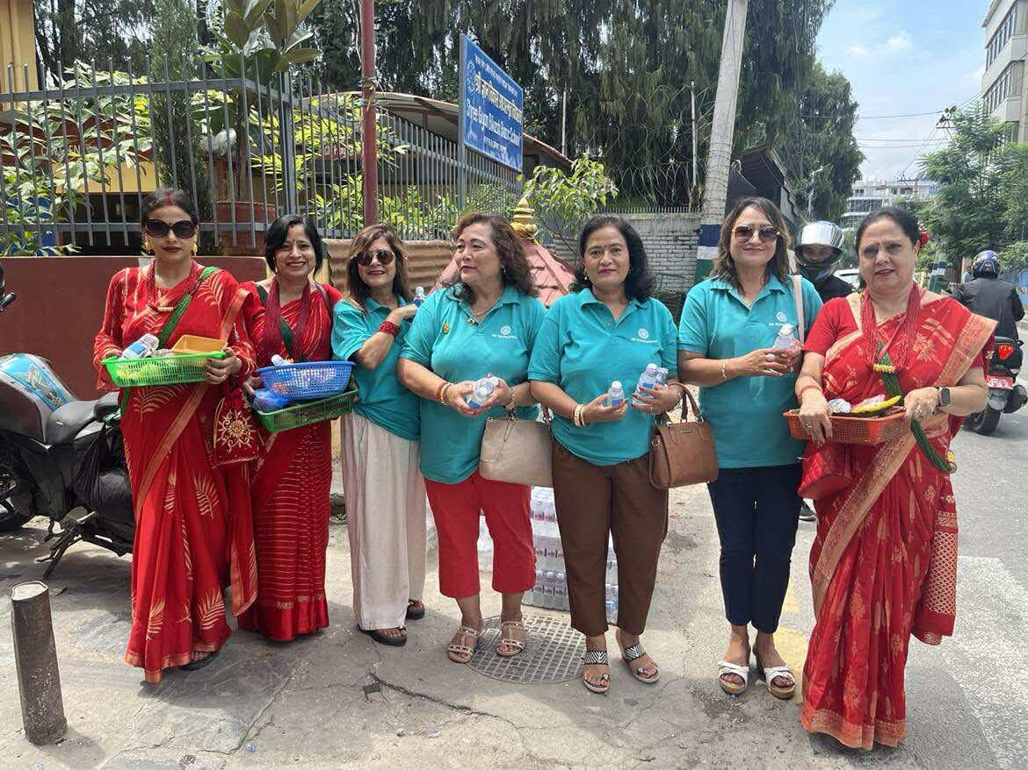
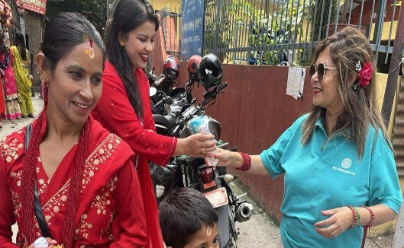

Written by: Service Project Chair, Rtn Pragya Pandey Gyawali
Checked & approved by: President, Rtn Sangeeta Sharma Dwivedi
Submitted by: Secretary, Rtn Sonu Dangol
Date: 5th September, 2025

