Title: Rotary Club of Himalayan Golfers Joins Tree Plantation initiative focusing on Native Plants and its Restoration
Date: July 26th, 2025
On July 26th, 2025, the Rotary Club of Himalayan Golfers (RCHG) proudly participated in a Native Forest Restoration/ tree plantation initiative held at Kirat Manghim Mandir, Lalitpur Ward 23. The program was organized in coordination with the Byawasthapan Samiti, the Jane Goodall Institute Nepal, and the Division Forest Office, aiming to restore and protect indigenous plant species through sustainable afforestation practices.
The restoration site was planted using the Miyawaki method, a proven Japanese afforestation technique that emphasizes planting dense clusters of native species in a small area to
encourage fast growth, biodiversity, and long-term survival. This method is especially effective in urban and degraded landscapes, helping reestablish native ecosystems.
The effort resulted in the plantation of:
- 250 native trees
- 200 vetivers
- 25 native species
(Kali Kath, Rittha, Puwale, Kaulo, Phalat, Lankure, Chap, Khari, Tejpat, Harro, Barro, Badahar, Chiuri, Kattus, Bel, Amala, Jamun, Lapsi, Parijat, Bimiro, Kafal, Aaru, Amba, Rajbrikshya, Okhar)
The total budget of NPR 320,000 was provided to the Jane Goodall Institute Nepal, covering all plant materials, administrative costs, and three years of post-plantation care and maintenance. The Institute has committed to providing a detailed progress report every three months, ensuring transparency and long-term sustainability of the forest site. The event reinforced Rotary’s values of preserving biodiversity and protecting the planet, aligning with Rotary’s area of focus: Supporting the Environment.

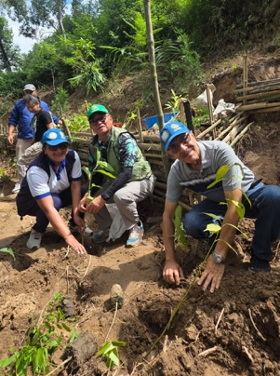
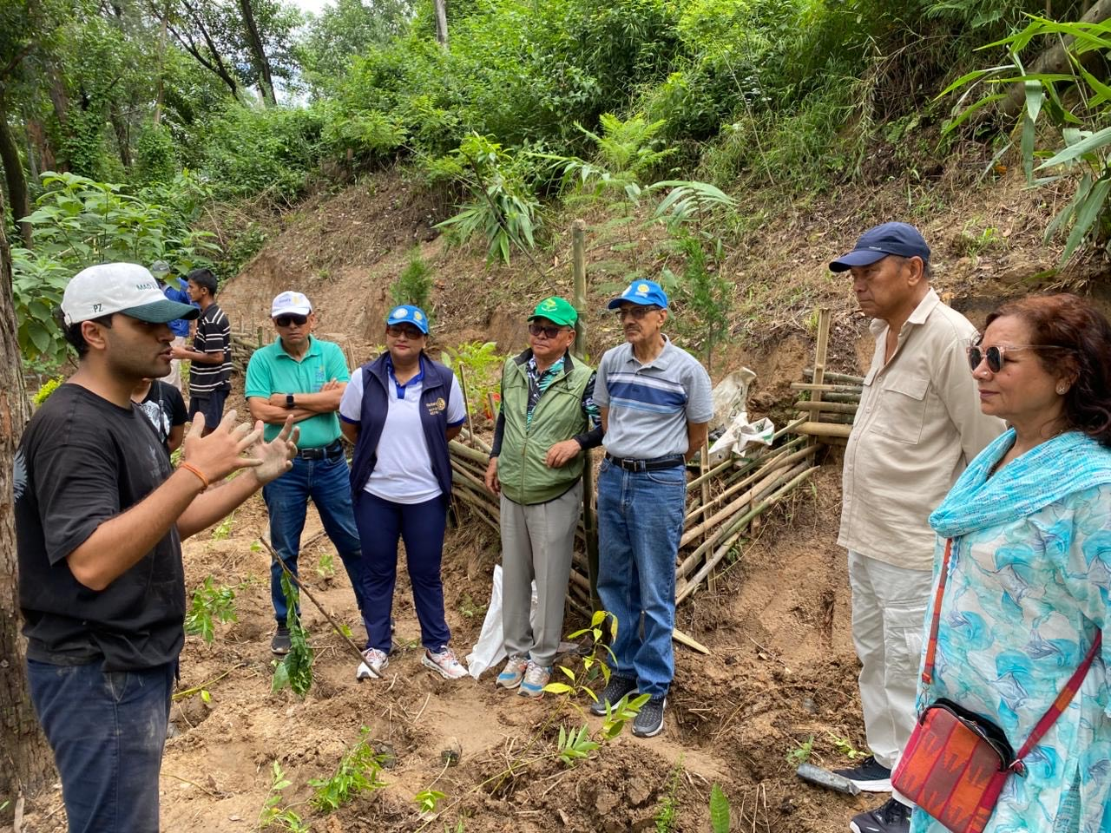
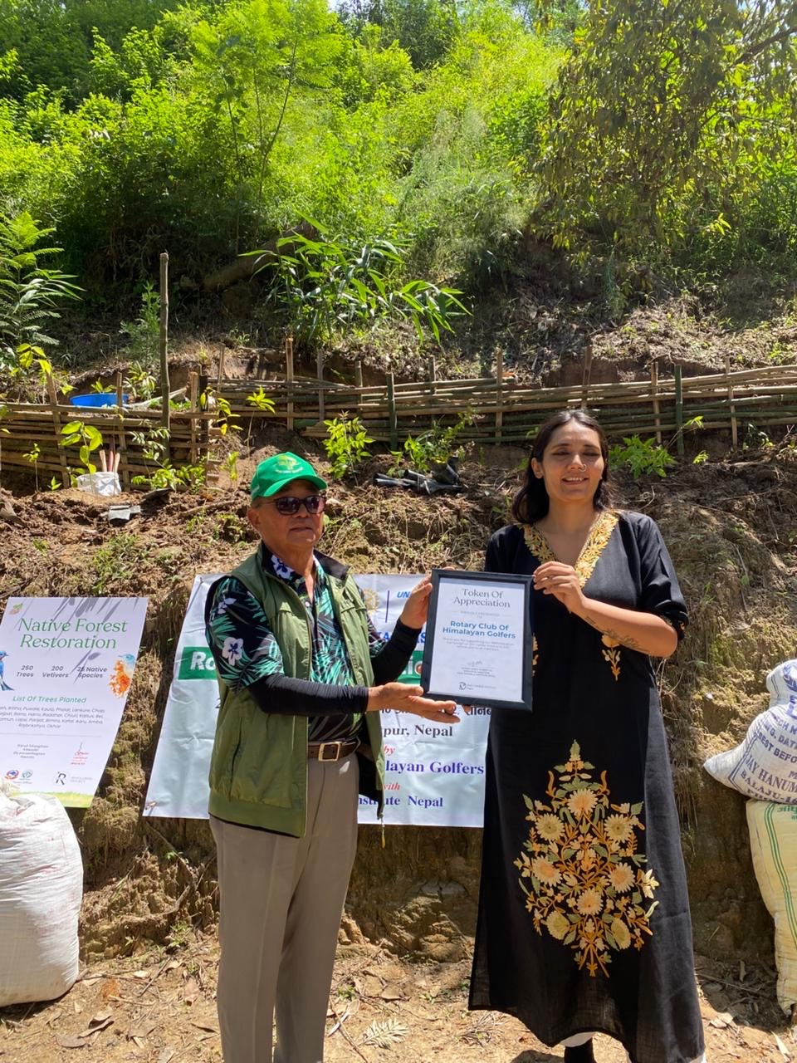
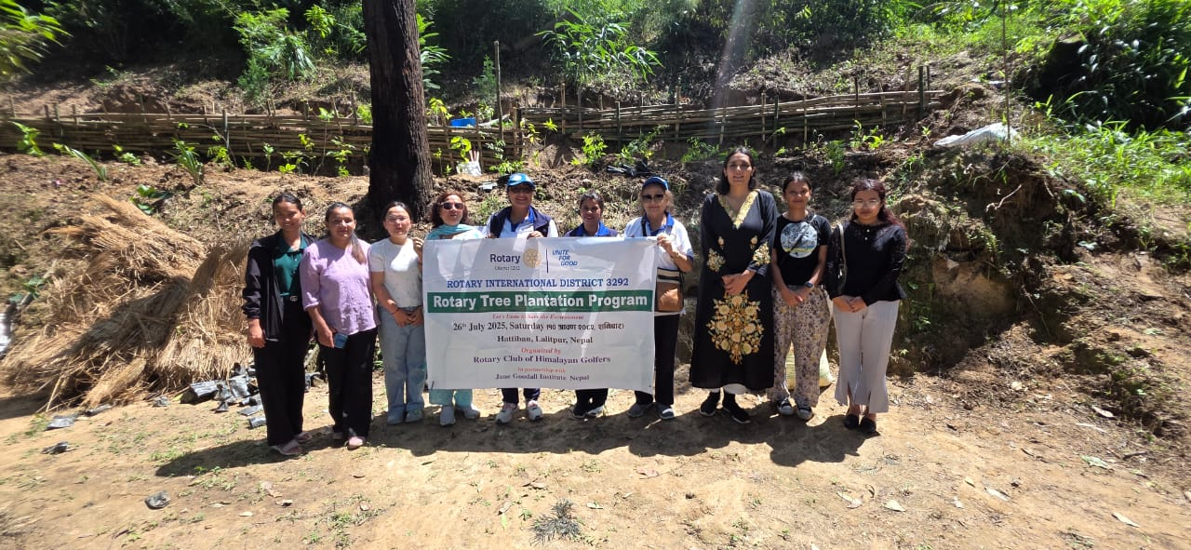
Pictures from the Event:

